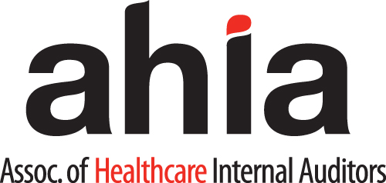
Tech Talk Subcommittee Charter
2018

MISSION
To ensure the Association of Healthcare Internal Auditors’ Tech Talk webinars support its mission and are responsive to the needs of Association membership and the profession at large.

ROLE
The Webinar Subcommittee is responsible for:
- Developing/overseeing 4 Tech Talk Webinars to be held quarterly, or as requested by Board.
- Determining topics and engaging speakers for each Tech Talk Webinar.
- Working closely with the other Virtual Learning Subcommittee Chairs to provide coordinated virtual learning events.
- Ensuring virtual learning events comply with all NASBA requirements.
- Ensuring virtual learning events support the certification process, while remaining independent.

Meetings
The Tech Talk Subcommittee will conduct the business of the subcommittee through an ongoing schedule of periodic (e.g. monthly, quarterly) conference calls and electronic communications. The Subcommittee will utilize a consensus decision making process when possible. When consensus decisions are not possible, decisions will be made by a simple majority of a roll call vote.

Membership
Subcommittee Leadership: The Tech Talk Subcommittee shall have a Chair that is a member in good standing of the Association as appointed by the Chair of the Virtual Learning Committee and the Board Liaison. The term of the Chair shall be for two years or until a successor is chosen by the Chair of the Virtual Learning Committee and approved by the Chair of the Board of Directors.
Other Subcommittee members shall include:
- The Chair of the Virtual Learning Subcommittee.
- The Board Liaison assigned to Virtual Learning by the Chair of the Board of Directors.
- Subcommittee members that are members in good standing of the Association.
- The Association's Education Director and/or Education Administrator (non-voting member).
- Total membership should not exceed eight voting members.

Responsibilities

The Chair is responsible for:
- Serving as Chair for all meetings of the Tech Talk Subcommittee.
- Coordinating with a member of the Tech Talk Subcommittee or the Virtual Learning Subcommittee Chair to Chair meetings in his or her absence.
- Coordinating the appointment of Tech Talk Subcommittee members with the Chair of the Virtual Learning Subcommittee.
- Working with the Virtual Learning Subcommittee Chair and Virtual Learning Board Liaison on the development of the Tech Talk Subcommittee charter and annual goals and objectives for review and approval by the Education Committee and Board of Directors.
- Coordinating the ongoing activities of the Tech Talk Subcommittee with those of the other Virtual Learning Subcommittee, Education Committee, and the Education Strategy.
- Coordinating the ongoing activities of Tech Talk Subcommittee to ensure educational offerings are aligned with the Body of Knowledge and support the certification process.
- Coordinating the ongoing activities of the Tech Talk Subcommittee to ensure topics and speakers are identified and approved for quarterly Tech Talk Webinars that are scheduled approximately six months in advance, materials are reviewed prior to each Webinar, and Webinar evaluation results are reviewed by the subcommittee and provided to each speaker in a timely manner.

The Association’s Education Director and staff shall be responsible for:
- Coordinating and scheduling Tech Talk Subcommittee conference calls.
- Producing minutes for Tech Talk Subcommittee meetings.
- Maintaining the Tech Talk Subcommittee roster.
- Maintaining the Tech Talk Webinar schedule and Webinar Worksheet.
- Scheduling Tech Talk Webinars with approved speakers, holding practice sessions with the speakers, conducting/ administering Tech Talk Webinars as scheduled, and providing Tech Talk Webinar evaluation results to the Tech Talk Subcommittee.

Revised and Approved by the Education Committee Co-Chairs and Board liaisons, 5/30/2018; Reviewed and Approved by the AHIA Board of Directors, 6/27/2018.

